AGENCY

Protected Utility

AGENCY - SOP - Renew MDM Server Token - Admin
 | 
Date 23 September 2020

Document Information

Document Acceptance for v1.0
Function | Date | Name | Position
Prepared: | 14-09-2020 | Collin McKeahnie | Consultant
Review | 21-09-2020 |  | Managing Consultant
Release | 22-09-2020 |  | Managing Consultant

Drafting and Release History
Version | Date | Author | Description
0.1 | 14-09-2020 | Collin McKeahnie | Initial Document
0.2 | 21-09-2020 |  | Review and update
1.0 | 22-09-2020 |  | Release

oobe contact details | oobe Pty Ltd
oobe contact details | | www.oobe.com.au  | GPO 111 Canberra City 2601  | ACN 123 977 846  | ABN 48 123 977 846

Contents
Renew MDM Server Token 4
Introduction 4
Purpose 4
Audience 4
Pre-Requisites 4
Renew MDM Token 5

Renew MDM Server Token

Introduction
The MDM Server token is required to link Microsoft Intune to the Apple Mobile Device Management Server. It has a validity of 365 days.

Purpose
This document is to guide an admin user through the process of renewing the MDM server token which is required to link the AGENCY Apple Business Manager account to Intune.

Audience
Admin users

Pre-Requisites
- Apple Business Manager account has been set up. The admin attempting the work has permission to access the portal.

Renew MDM Token
Step | Instruction | Screen Shot
 | Log into the Apple Business Manager Account at https://business.apple.com  Username: applemobile@AGENCY.gov.au  Password: Stored by AGENCY | 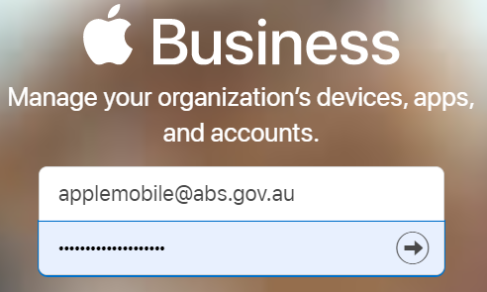
 | Select Settings from the bottom of the left side menu | 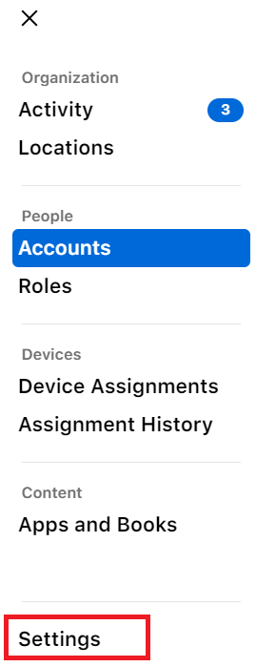
 | Select MDM Server from the settings menu | 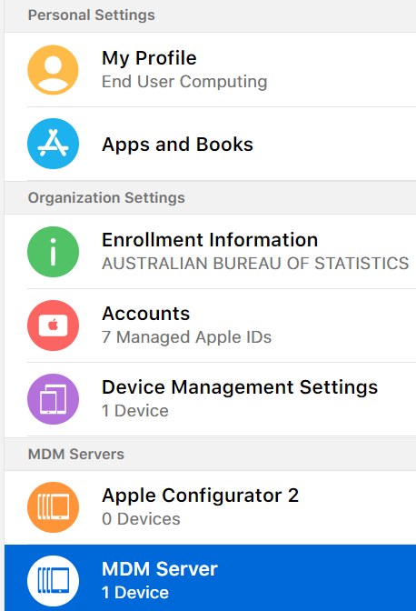
 | Click the Download Token from the top of the MDM Server settings page | 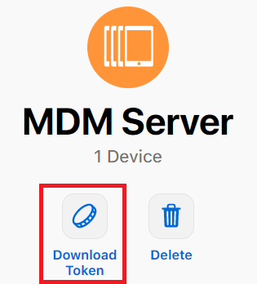
 | Log into the Microsoft Endpoint Manager at https://endpoint.microsoft.com and select Devices | 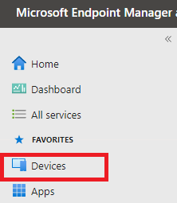
 | From the devices blade select iOS/iPadOS | 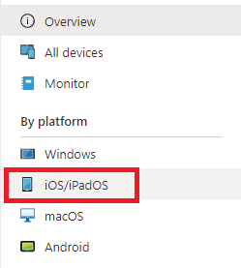
 | From the iOS/iPadOS blade select iOS/iPadOS enrolment | 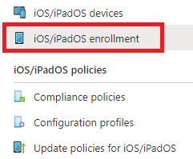
 | Under Bulk enrolment methods select Enrolment program tokens | 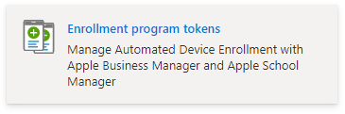
 | Select the Token name for the appropriate Apple ID | 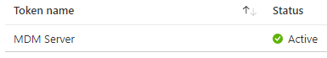
 | Select Renew token | 
 | From the Renew token page select the file you downloaded at step 4 as the Apple token | 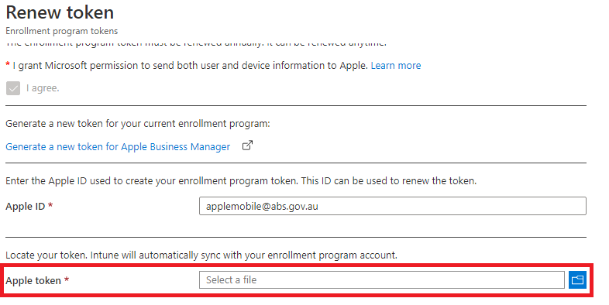
 | Select Next | 
 | Select Create | 

